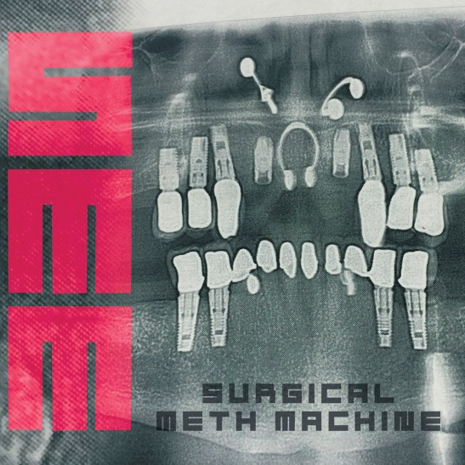

**SURGICAL**

**METH MACHINE**

»Surgical Meth Machine«

*OUT: April, 15th 2016*

|  |  |
| --- | --- |
| **Line up:** | **SURGICAL METH MACHINE online:** |
| Al Jourgensen | [www.alfuckingjourgensen.com](http://www.alfuckingjourgensen.com)  [www.facebook.com/ministry](http://www.facebook.com/ministry)  [www.nuclearblast.de/surgicalmethmachine](http://www.nuclearblast.de/surgicalmethmachine) |

Whether it’s called crystal, chalk, ice, meth, or the fictitious Blue Sky immortalized in **»Breaking Bad«**, there’s no mistaking the effects of the powerful methamphetamine stimulant that’s ruined lives and blown up homemade labs around the world. Meth accelerates the heart, to say the least. Now imagine that unrelenting adrenalized rush delivered with the precision of a highly skilled physician and supercharged by a human engine whose very name is synonymous with industrial might.

**SURGICAL METH MACHINE** is the bipolar album this bipolar world demands, a rollercoaster ride through demented fever dreams, chillingly morose melodicism, and breakneck acceleration toward impossible speeds and gasoline soaked thrills, all from the always-deliciously-terrible-to-taste mind of **MINISTRY**’s **Al Jourgensen**.

The declaration of war against empty criticism that is **'I’m Sensitive'** sets the tone for the first half of the album, as tracks like **'Tragic Alert'** and **'Rich People Problems'** blast by like a thousand meteors hurtling into the sun. In stark contrast, sublime songs like **'Just Go Home,'** **'Just Keep Going'** and the comedown album closer **'I’m Invisible'** are among **Jourgensen**’s most diverse work of his 35-year strong career.

*“Going through this album is a really long, strange journey,”* **Jourgensen** explains. *“The album starts out beating you over the head with some of the fastest stuff that’s probably ever been recorded, at least that’s cohesive. Then it ends sounding damn near like a lounge act, with me crooning like Wayne Newton or some shit.”*

As leader of **MINISTRY**, **Jourgensen**’s unapologetically aggressive and heavy-metal-strengthened contributions to industrial music across 13 studio albums is without peer or precedent, alongside his contemporaries in **NINE** **INCH** **NAILS** and **SKINNY** **PUPPY**. **MINISTRY** classics like **'Stigmata,'** **'Thieves,'** **'(Every Day Is) Halloween,'** and the ubiquitous MTV staple **'Jesus Built My Hotrod'** are anthems for the underclass around the world, each of them destined for some post-apocalyptic time capsule designed to inform some future civilization of the destructive pains of the nuclear proliferation age.

Chronicled in his barn burning page turner of an autobiography **»Ministry: The Lost Gospels According To Al Jourgensen«**, the industrial-metal legend has lived a life of urgent artistic destruction, biting social commentary, fierce individualism, and death-defying excess. **Jourgensen** says he’s met death face-to-face three times already, flat-lining most recently from massive internal bleeding that threatened to end his musical career forever. **SURGICAL** **METH** **MACHINE** is both the triumphant sound of resilience and defiance in the face of insurmountable odds and the beautiful comedown of positive personal change and catharsis, all in one explosive album.

The album was crafted off-and-on over a period of 12 months, mostly in the Cuban-American singer and multi-instrumentalist’s Burbank, California studio with longtime engineer **Sam D’Ambruoso**. **Jourgensen**’s longtime guitarist and friend, the late **Mike Scaccia**, served as partial inspiration for what would become **SURGICAL** **METH** **MACHINE**. **Scaccia** first appeared on a **MINISTRY** album in 1992, **»Psalm 69«**, one of a string of commercial and critical breakthrough albums that also included the industrial/rock standard **»The Land Of Rape And Honey«** (1986) and **»The Mind Is A Terrible Thing To Taste«** (1989).

*“[D’Ambruoso] and I wanted to do a really fast record, which we’d discussed with Mikey as well,”* **Jourgensen** says. *“He was one of the fastest guitar players who ever lived. This music was definitely originally concocted to be extra super-fast, faster than ridiculous. But we did it in a studio way so it's very surgical and clinical.”*

*“The first five songs are really heavy on the speed/adrenaline aspect. It's a speed metal listener's wet dream,”* he adds. *“The tempos and beats I don't think have been approached to this level before. We were joking about how playing this stuff live would literally cause heart attacks within the band just trying to keep up with the pace.”*

**Jourgensen** has experimented with everything from heavy metal and industrial to country and jazz, with other projects still up his sleeve that are yet to be unveiled. The genesis and direction of **SURGICAL** **METH** **MACHINE** was incredibly and exhilaratingly specific. Unburdened by the **MINISTRY** name and all that the legacy represents, **SURGICAL** **METH** **MACHINE** was free to forge to a singular identity. Strangely, that freedom ultimately led him to come full circle, all the way back to **MINISTRY**’s Euro synthpop driven debut album, **»With Sympathy«** (1983), through the post-industrial/electropunk EBM follow-up, **»Twitch«** (1986), to the more recognizable **MINISTRY** sound that continues to this day.

*“By the end we started realizing that this is more of a MINISTRY record than any MINISTRY record,”* **Jourgensen** says, with a knowing laugh. *“It doesn’t sound like MINISTRY. What I mean is that if you look at the whole career of MINISTRY starting out with pop and then branching out into a lot of different things, we found ourselves using every bit of the MINISTRY catalog. I felt like I was on the old TV show »This Is Your Life«.”*

**SURGICAL** **METH** **MACHINE** rewards listeners with massive highs and soul soothing lows, all without the side effects of true chemical indulgence.

To put it simply: **Walter White** ain’t got nothing on Uncle **Al**.